- A standard photo-shoot will usually take no more than 2 hours. Time increases if video or aerial (Drone) footage is added. I will be photographing both the inside and outside of your home. I’ll be photographing all of the major rooms. We normally do not photograph the garage unless it has special features or is requested.

- If you have special features of your home that are not obvious. Please let me know about these so I include them in the shoot.

- Contain pets out of sight

- Remove all vehicles from driveways and do not park directly in front of the house.

- Move garbage cans out of sight.

- Remove all garden tools including hoses and sprinklers.

- Mow and rake yard

- Sweep driveways, sidewalks and patios

- Clear off counter tops in kitchen and bathroom areas

- Remove magnets, photos, notes and papers from the refrigerator

- Turn on all interior lights.

- Adjust Blinds, Curtains (Open if there is a View) and Shower Curtains accordingly

- Turn ceiling fans and televisions off. Rotating Ceiling Fans Cause Motion Blur

- De-clutter rooms which may be excessively furnished. They do not photograph well.

- Make all beds and tidy bedrooms. Clothes hung, or folded an put away.

- Remove piles of newspaper and magazines.

- Tuck trash cans out of view in a closet or cupboard.

The More Appealing the Home the Greater the Interest to a Potential Buyer!

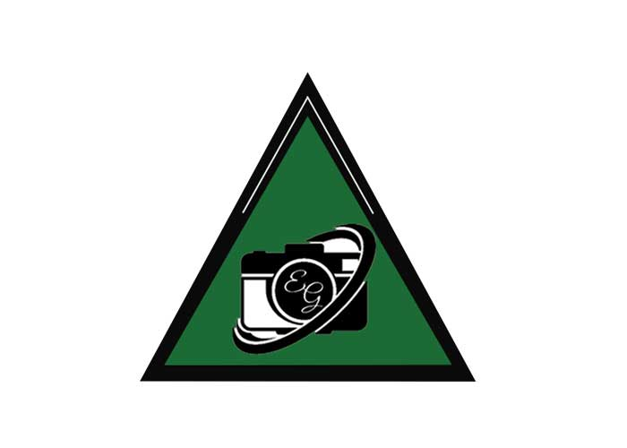

2021 Evergreen Real Estate Photography, LLC 360-773-3639

